Objective:

BookBot suggests the top rated book on Amazon for a given technical topic. The basic utterance is: 'suggest a <title> book'.

Example: 'suggest a python book'

Testing Instructions:

One can initiate the bot with a greeting such as 'hi' or 'hello', the bot will greet and expect the user to enter a technical topic or use the bot's suggestions(buttons) to get the top rated book for the given topic

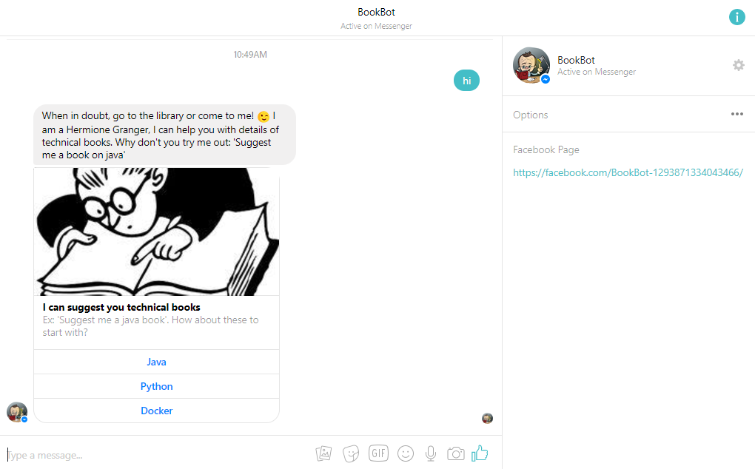

The bot can give you the following details for a book, suggested on the given topic:

1. Authors:

The bot can give you the details of the author and also their most popular book

Sample Utterance: who is the author?

2. Cost:

Returns the price of the book

Sample Utterance: what is the cost?

3. Reviews:

Returns a URL for the reviews of the book

Sample Utterance: reviews?

4. Pages:

Returns the number of pages

Sample Utterance: Number of pages?

5. More Options:

Returns tiles of books similar to the suggested book

Sample Utterance: show more options

6. Publisher:

Returns the publisher details

Sample Utterance: who is the publisher?

7. Cover-pic:

Returns the cover picture of the book

Sample Utterance: show me the cover picture